**Q1: Can you create a basic HTML search form with a text input and a submit button?**

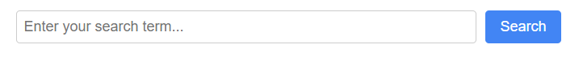

<!DOCTYPE html>

<html>

<head>

<title>Basic Search Form</title>

<style>

body {

font-family: Arial, sans-serif;

max-width: 600px;

margin: 0 auto;

padding: 20px;

}

.search-form {

display: flex;

gap: 10px;

}

.search-input {

padding: 8px;

font-size: 16px;

flex-grow: 1;

border: 1px solid #ccc;

border-radius: 4px;

}

.search-button {

padding: 8px 16px;

background-color: #4285f4;

color: white;

border: none;

border-radius: 4px;

cursor: pointer;

font-size: 16px;

}

.search-button:hover {

background-color: #3367d6;

}

</style>

</head>

<body>

<form class="search-form" action="/search" method="get">

<input

type="text"

name="q"

class="search-input"

placeholder="Enter your search term..."

aria-label="Search"

>

<button type="submit" class="search-button">Search</button>

</form>

</body>

</html>

**Q2: Generate a search form with filters including a keyword field, a category dropdown, and date range inputs using HTML and basic styling.**

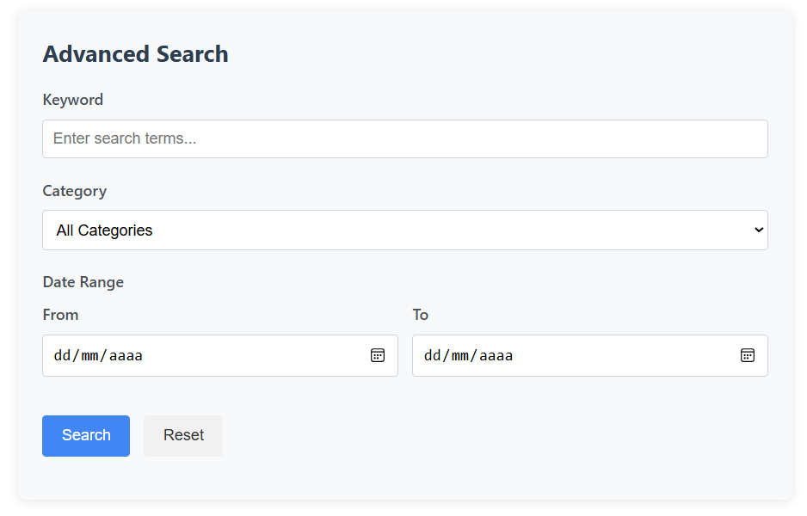

<!DOCTYPE html>

<html lang="en">

<head>

<meta charset="UTF-8">

<meta name="viewport" content="width=device-width, initial-scale=1.0">

<title>Advanced Search Form</title>

<style>

body {

font-family: 'Segoe UI', Tahoma, Geneva, Verdana, sans-serif;

line-height: 1.6;

color: #333;

max-width: 800px;

margin: 0 auto;

padding: 20px;

}

.search-container {

background-color: #f8f9fa;

padding: 25px;

border-radius: 8px;

box-shadow: 0 2px 10px rgba(0, 0, 0, 0.1);

}

.search-title {

margin-top: 0;

color: #2c3e50;

font-size: 24px;

}

.form-group {

margin-bottom: 20px;

}

label {

display: block;

margin-bottom: 8px;

font-weight: 600;

color: #495057;

}

input[type="text"],

input[type="date"],

select {

width: 100%;

padding: 10px;

border: 1px solid #ced4da;

border-radius: 4px;

font-size: 16px;

box-sizing: border-box;

}

.date-range {

display: flex;

gap: 15px;

}

.date-range .form-group {

flex: 1;

}

.search-button {

background-color: #4285f4;

color: white;

border: none;

padding: 12px 20px;

font-size: 16px;

border-radius: 4px;

cursor: pointer;

transition: background-color 0.3s;

}

.search-button:hover {

background-color: #3367d6;

}

.reset-button {

background-color: #f1f1f1;

color: #333;

border: none;

padding: 12px 20px;

font-size: 16px;

border-radius: 4px;

cursor: pointer;

margin-left: 10px;

transition: background-color 0.3s;

}

.reset-button:hover {

background-color: #e2e2e2;

}

</style>

</head>

<body>

<div class="search-container">

<h1 class="search-title">Advanced Search</h1>

<form action="/search" method="get">

<!-- Keyword Search -->

<div class="form-group">

<label for="keyword">Keyword</label>

<input type="text" id="keyword" name="q" placeholder="Enter search terms...">

</div>

<!-- Category Dropdown -->

<div class="form-group">

<label for="category">Category</label>

<select id="category" name="category">

<option value="">All Categories</option>

<option value="technology">Technology</option>

<option value="business">Business</option>

<option value="health">Health</option>

<option value="education">Education</option>

<option value="entertainment">Entertainment</option>

</select>

</div>

<!-- Date Range -->

<div class="form-group">

<label>Date Range</label>

<div class="date-range">

<div class="form-group">

<label for="start-date">From</label>

<input type="date" id="start-date" name="start_date">

</div>

<div class="form-group">

<label for="end-date">To</label>

<input type="date" id="end-date" name="end_date">

</div>

</div>

</div>

<!-- Buttons -->

<div class="form-group">

<button type="submit" class="search-button">Search</button>

<button type="reset" class="reset-button">Reset</button>

</div>

</form>

</div>

</body>

</html>

**Q3: Build a styled HTML and JavaScript form that allows users to search using keywords, category filters, and a date range, and shows a filtered results table dynamically.**

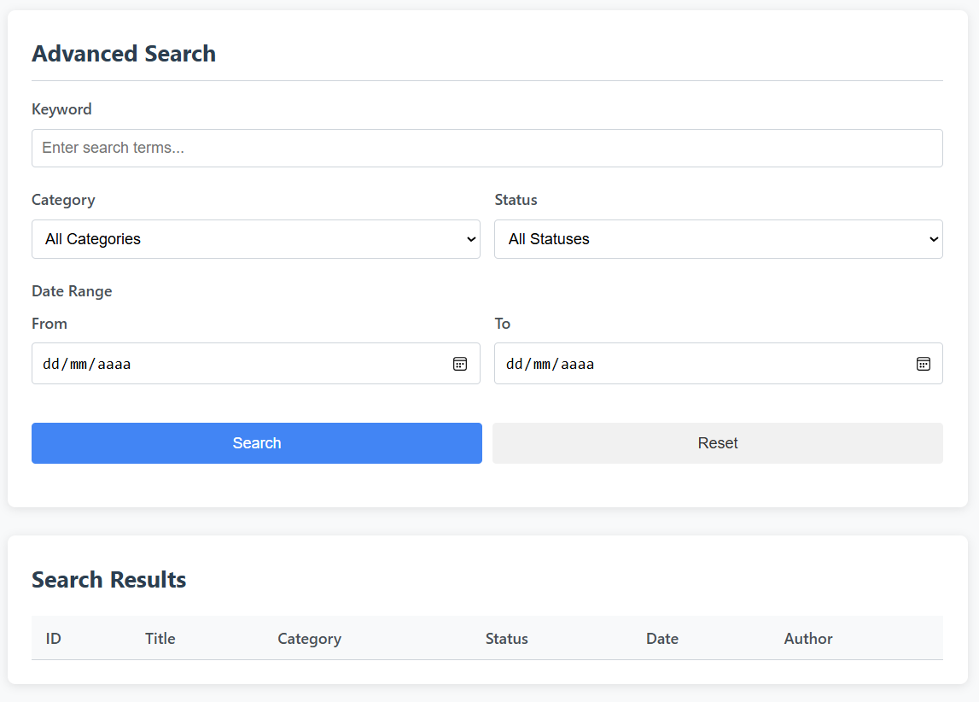

<!DOCTYPE html>

<html lang="en">

<head>

<meta charset="UTF-8">

<meta name="viewport" content="width=device-width, initial-scale=1.0">

<title>Dynamic Search with Filters</title>

<style>

:root {

--primary-color: #4285f4;

--primary-hover: #3367d6;

--secondary-color: #f1f1f1;

--secondary-hover: #e2e2e2;

--text-color: #333;

--light-text: #6c757d;

--border-color: #ced4da;

--shadow: 0 2px 10px rgba(0, 0, 0, 0.1);

}

body {

font-family: 'Segoe UI', Tahoma, Geneva, Verdana, sans-serif;

line-height: 1.6;

color: var(--text-color);

max-width: 1000px;

margin: 0 auto;

padding: 20px;

background-color: #f8f9fa;

}

.search-container {

background-color: white;

padding: 25px;

border-radius: 8px;

box-shadow: var(--shadow);

margin-bottom: 30px;

}

.search-title {

margin-top: 0;

color: #2c3e50;

font-size: 24px;

border-bottom: 1px solid var(--border-color);

padding-bottom: 10px;

}

.form-group {

margin-bottom: 20px;

}

label {

display: block;

margin-bottom: 8px;

font-weight: 600;

color: #495057;

}

input[type="text"],

input[type="date"],

select {

width: 100%;

padding: 10px;

border: 1px solid var(--border-color);

border-radius: 4px;

font-size: 16px;

box-sizing: border-box;

}

.filter-row {

display: flex;

gap: 15px;

}

.filter-row .form-group {

flex: 1;

}

.button-group {

display: flex;

gap: 10px;

}

.search-button {

background-color: var(--primary-color);

color: white;

border: none;

padding: 12px 20px;

font-size: 16px;

border-radius: 4px;

cursor: pointer;

transition: background-color 0.3s;

flex: 1;

}

.search-button:hover {

background-color: var(--primary-hover);

}

.reset-button {

background-color: var(--secondary-color);

color: var(--text-color);

border: none;

padding: 12px 20px;

font-size: 16px;

border-radius: 4px;

cursor: pointer;

transition: background-color 0.3s;

flex: 1;

}

.reset-button:hover {

background-color: var(--secondary-hover);

}

.results-container {

background-color: white;

padding: 25px;

border-radius: 8px;

box-shadow: var(--shadow);

}

.results-title {

margin-top: 0;

color: #2c3e50;

}

table {

width: 100%;

border-collapse: collapse;

margin-top: 20px;

}

th, td {

padding: 12px 15px;

text-align: left;

border-bottom: 1px solid var(--border-color);

}

th {

background-color: #f8f9fa;

font-weight: 600;

color: #495057;

}

tr:hover {

background-color: #f8f9fa;

}

.no-results {

text-align: center;

padding: 20px;

color: var(--light-text);

font-style: italic;

}

.highlight {

background-color: #fffde7;

font-weight: bold;

}

</style>

</head>

<body>

<div class="search-container">

<h1 class="search-title">Advanced Search</h1>

<form id="searchForm">

<!-- Keyword Search -->

<div class="form-group">

<label for="keyword">Keyword</label>

<input type="text" id="keyword" name="q" placeholder="Enter search terms...">

</div>

<!-- Filter Row -->

<div class="filter-row">

<!-- Category Dropdown -->

<div class="form-group">

<label for="category">Category</label>

<select id="category" name="category">

<option value="">All Categories</option>

<option value="technology">Technology</option>

<option value="business">Business</option>

<option value="health">Health</option>

<option value="education">Education</option>

<option value="entertainment">Entertainment</option>

</select>

</div>

<!-- Status Dropdown -->

<div class="form-group">

<label for="status">Status</label>

<select id="status" name="status">

<option value="">All Statuses</option>

<option value="active">Active</option>

<option value="pending">Pending</option>

<option value="completed">Completed</option>

</select>

</div>

</div>

<!-- Date Range -->

<div class="form-group">

<label>Date Range</label>

<div class="filter-row">

<div class="form-group">

<label for="start-date">From</label>

<input type="date" id="start-date" name="start_date">

</div>

<div class="form-group">

<label for="end-date">To</label>

<input type="date" id="end-date" name="end_date">

</div>

</div>

</div>

<!-- Buttons -->

<div class="form-group">

<div class="button-group">

<button type="submit" class="search-button">Search</button>

<button type="reset" class="reset-button">Reset</button>

</div>

</div>

</form>

</div>

<div class="results-container">

<h2 class="results-title">Search Results</h2>

<div id="resultsCount"></div>

<div id="resultsTable">

<table>

<thead>

<tr>

<th>ID</th>

<th>Title</th>

<th>Category</th>

<th>Status</th>

<th>Date</th>

<th>Author</th>

</tr>

</thead>

<tbody id="resultsBody">

<!-- Results will be inserted here by JavaScript -->

</tbody>

</table>

</div>

</div>

<script>

// Sample data - in a real app, this would come from an API

const sampleData = [

{ id: 1, title: "Introduction to JavaScript", category: "technology", status: "active", date: "2023-05-15", author: "Jane Doe" },

{ id: 2, title: "Market Trends 2023", category: "business", status: "active", date: "2023-06-20", author: "John Smith" },

{ id: 3, title: "Healthy Eating Habits", category: "health", status: "completed", date: "2023-04-10", author: "Alice Johnson" },

{ id: 4, title: "Modern Teaching Methods", category: "education", status: "pending", date: "2023-07-05", author: "Robert Brown" },

{ id: 5, title: "New Movie Releases", category: "entertainment", status: "active", date: "2023-06-25", author: "Emily Davis" },

{ id: 6, title: "Advanced React Patterns", category: "technology", status: "active", date: "2023-05-30", author: "Mike Wilson" },

{ id: 7, title: "Financial Planning Guide", category: "business", status: "completed", date: "2023-03-18", author: "Sarah Miller" },

{ id: 8, title: "Mental Health Awareness", category: "health", status: "pending", date: "2023-07-12", author: "David Taylor" },

{ id: 9, title: "Online Learning Platforms", category: "education", status: "active", date: "2023-06-08", author: "Laura Anderson" },

{ id: 10, title: "Summer Music Festivals", category: "entertainment", status: "completed", date: "2023-05-22", author: "James White" }

];

document.addEventListener('DOMContentLoaded', function() {

// Initial load - show all data

displayResults(sampleData);

// Form submission handler

document.getElementById('searchForm').addEventListener('submit', function(e) {

e.preventDefault();

const filteredData = filterData();

displayResults(filteredData);

});

// Reset form handler

document.getElementById('searchForm').addEventListener('reset', function() {

// Small delay to allow form to reset before filtering

setTimeout(() => {

displayResults(sampleData);

}, 10);

});

});

function filterData() {

const keyword = document.getElementById('keyword').value.toLowerCase();

const category = document.getElementById('category').value;

const status = document.getElementById('status').value;

const startDate = document.getElementById('start-date').value;

const endDate = document.getElementById('end-date').value;

return sampleData.filter(item => {

// Keyword search (title and author)

const matchesKeyword = keyword === '' ||

item.title.toLowerCase().includes(keyword) ||

item.author.toLowerCase().includes(keyword);

// Category filter

const matchesCategory = category === '' || item.category === category;

// Status filter

const matchesStatus = status === '' || item.status === status;

// Date range filter

let matchesDate = true;

if (startDate) {

matchesDate = matchesDate && item.date >= startDate;

}

if (endDate) {

matchesDate = matchesDate && item.date <= endDate;

}

return matchesKeyword && matchesCategory && matchesStatus && matchesDate;

});

}

function displayResults(data) {

const resultsBody = document.getElementById('resultsBody');

const resultsCount = document.getElementById('resultsCount');

const keyword = document.getElementById('keyword').value.toLowerCase();

// Clear previous results

resultsBody.innerHTML = '';

if (data.length === 0) {

resultsBody.innerHTML = '<tr><td colspan="6" class="no-results">No results found matching your criteria</td></tr>';

resultsCount.textContent = '0 results found';

return;

}

// Update results count

resultsCount.textContent = `${data.length} ${data.length === 1 ? 'result' : 'results'} found`;

// Add each result to the table

data.forEach(item => {

const row = document.createElement('tr');

// Highlight matching text in title

let title = item.title;

if (keyword) {

const regex = new RegExp(keyword, 'gi');

title = title.replace(regex, match => `<span class="highlight">${match}</span>`);

}

row.innerHTML = `

<td>${item.id}</td>

<td>${title}</td>

<td>${capitalizeFirstLetter(item.category)}</td>

<td>${capitalizeFirstLetter(item.status)}</td>

<td>${formatDate(item.date)}</td>

<td>${item.author}</td>

`;

resultsBody.appendChild(row);

});

}

// Helper functions

function capitalizeFirstLetter(string) {

return string.charAt(0).toUpperCase() + string.slice(1);

}

function formatDate(dateString) {

const options = { year: 'numeric', month: 'short', day: 'numeric' };

return new Date(dateString).toLocaleDateString(undefined, options);

}

</script>

</body>

</html>